Drought Climatology in Missouri:

# Introduction:

## What is drought?

Drought as an overarching term is defined as “a prolonged period of abnormally low rainfall, leading to a shortage of water.” According to the Oxford Languages Dictionary. This, however, is not nuanced enough for our purposes. Instead of using the overarching definition, it is best to define drought in distinct categories. The National Weather Service Classifies Drought in the following categories.[[1]](https://www.weather.gov/safety/drought-types)

* **Meteorological Drought:** Based solely on the amount of rainfall that has occurred in a region over a given amount of time. The less rainfall, the more severe the drought.
* **Hydrological Drought:** Based on the impact that meteorological drought has on a water supply. This could be a lake, stream, river, etc.
* **Agricultural Drought:** Based on the impacts that both meteorological and hydrological drought may have on soil, irrigation, etc.
* **Socioeconomic Drought:** Based on the impacts of meteorological, hydrological, and agricultural drought on the supply and/or demand of goods that depend on water for production. Fruits, vegetables, grains, meat, etc. The National Weather Service explicitly defines this as: “when the demand for an economic good exceeds supply as a result of a weather-related deficit in water supply.”

For the purposes of this study, we will be exclusively looking at meteorological drought. This is because we will be using precipitation data exclusively. It should be noted that the impacts of precipitation deficits (meteorological drought) extend into hydrological, agricultural, and socioeconomic drought. In this way the study will be useful for assessing all types of droughts to some degree but will only be directly analyzing meteorological drought. For more information on how drought was calculated, and the exact thresholds used for drought classification, go to the “Data and Methodology” section of this text (pg. _).

## Why Understand Drought Climatology in Missouri?

Droughts unfortunately are common in the state and happen at all levels from meteorological to socioeconomic. According to the NCEI Billion Dollar Disaster database[[2](https://www.ncei.noaa.gov/access/billions/time-series/MO/cost)], Missouri has had 15 drought years from 1980-2024, which is 34% of the period. The costliest of these droughts was in 2012. Costs from that drought are estimated to be between 2 and 5 billion dollars (CPI-adjusted). The examination of meteorological drought data can be used to mitigate the impacts of meteorological drought, therefore lessening hydrological, agricultural, and socioeconomic impacts. For example, the seasonality of drought is important for those in agriculture to know whether drought onset is becoming a “new normal” every growing season. Precipitation deficits are also an early indicator for agricultural and hydrological drought impacts. By putting emphasis on precipitation, we can better predict and understand the stresses meteorological drought applies.

## Objectives of this study:

The objective of this study is to study the history of drought over the past 24 years, breaking down how often droughts happen, how long they last, which droughts are most severe, and most importantly, any patterns that can help us predict drought. We will use Missouri Mesonet data to understand the drought characteristics mentioned above, and share our findings here, to be used by the public and researchers alike to better understand Missouri’s drought characteristics.

# Data and Methodology:

## Spatial and Temporal Coverage of Analysis:

The drought climatology analysis done for the State of Missouri includes every Missouri Mesonet station within the state that passed quality control checks. Analysis was done for the following locations:

* Albany, Gentry County, MO
* Auxvasse, Audrain County, MO
* Brunswick, Carroll County, MO
* Cardwell, Dunklin County, MO
* Charleston, Mississippi County, MO
* Clarkton, Dunklin County, MO
* Columbia-Sanborn Field, Boone County, MO
* Columbia-South Farms, Boone County, MO
* Cook Station, Crawford County, MO
* Corning, Atchison County, MO
* Delta, Cape Girardeau County, MO
* Glennonville, Dunklin County, MO
* Hayward, Pemiscot County, MO
* Lamar, Barton County, MO
* Linneus, Linn County, MO
* Monroe City, Monroe County, MO
* Novelty, Knox County, MO
* Portageville, Pemiscot County, MO
* St. Joseph, Buchanan County, MO

Temporal coverage at every location listed above is from January 1st, 2000 to May 31st, 2024. Raw data was daily and converted to monthly for the purposes of this study.

This 24 year period of record, while robust does pose a limitation of being under the standard 30 year period of record recommended for climatological study. A 30 year period tends to do a good job of capturing and “smoothing out” extreme events in a way that is representative of an areas overall behavior. At 24 years, individual extreme events, or a lack thereof, can change the results of the analysis more than we would like. So, while the period of record is sufficient for our purposes, the limitations of this period are important to make clear.

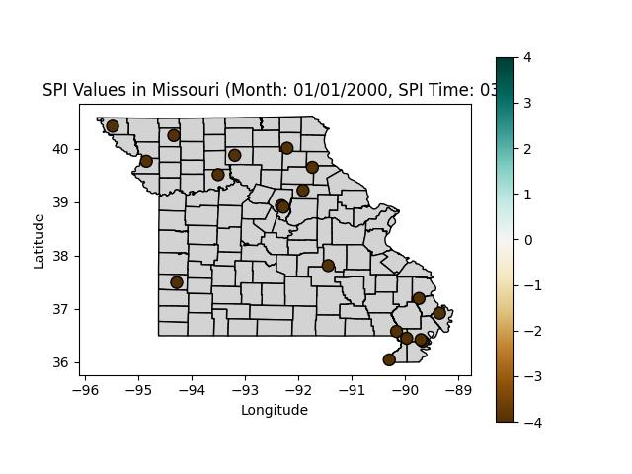

## Data Sources:

Data was almost exclusively obtained from Missouri Mesonet stations.[[2]](http://agebb.missouri.edu/weather/stations/) This was done because one of the main objectives of this study is to show the utility of the Missouri Mesonet in serving the public. Other data sources were needed, however, in the scenario that data from a Mesonet station was missing for a small, period of time, as the completeness of the dataset is not a trivial matter. We determined that up to 8 months of data missing was acceptable, if more than that was missing, the mesonet station in question was not used for this analysis. Other sources were National Weather Service Cooperative Observer Program(NWS COOP) stations[[3]](https://www.weather.gov/coop/), within 10 miles of the mesonet station in most cases (exceptions explicitly stated in the Data Quality Control section), and the National Water Prediction Center Precipitation Estimate (Multi-Sensor Data)[[4]](https://water.noaa.gov).

## Data Quality Control:

Data quality control was done through a mix of automated and manual steps. A python program was written to inspect the data of each mesonet and output the following characteristics about the data. File name (Location), the first and last day of data in the file. The highest and lowest precipitation values during the period, as well as missing days in the file. These outputs were manually looked through and used to ensure that data was the way you’d expect it to be. There were some tweaks that needed to be made to the data to ensure it passed quality control.

First, the complete archive of Missouri Mesonet daily precipitation data from every station that is currently operational and has ever been operational was manually downloaded. Each of these files were text files, which were then run through the quality control program mentioned above. With the outputted quality control statistics, it was time to make some decisions regarding which data was going to be in use, and which data wasn’t. A complete list of every station’s evaluation, with an assessment of it’s usability, the reasons for that, and where/when alternative data sources were used to fill in gaps is found in Appendix A.

## Calculation of SPI (Standard Precipitation Index):

Standardized Precipitation Index (SPI) is a widely used metric for quantifying precipitation deficits and surpluses, which allows for assessing drought conditions. To transform raw precipitation data into SPI values, we elected to use the National Drought Mitigation Center’s SPI Generator.

SPI is calculated by taking a large amount of data in constant time intervals, and calculating how common it is that *at least* the given value of precipitation falls on a given day. From there explicit SPI values are calculated. Positive SPI values indicate wet conditions, while negative SPI values indicate dry conditions.

The U.S. Drought Monitor uses SPI as a general gauge for drought severity. SPI can be interpreted as follows:

***This comes directly from*** [***https://droughtmonitor.unl.edu/About/AbouttheData/DroughtClassification.aspx***](https://droughtmonitor.unl.edu/About/AbouttheData/DroughtClassification.aspx)

| **Category** | **Description** | **Example Percentile Range for Most Indicators** | **Values for Standard Precipitation Index and Standardized Precipitation-Evapotranspiration Index** |
| --- | --- | --- | --- |
| **None** | Normal or wet conditions | 30.01 or Above | -0.49 or above |
| **D0** | Abnormally Dry | 20.01 to 30.00 | -0.5 to -0.79 |
| **D1** | Moderate Drought | 10.01 to 20.00 | -0.8 to -1.29 |
| **D2** | Severe Drought | 5.01 to 10.00 | -1.3 to -1.59 |
| **D3** | Extreme Drought | 2.01 to 5.00 | -1.6 to -1.99 |
| **D4** | Exceptional Drought | 0.00 to 2.00 | -2.0 or less |

The National Drought Mitigation Center SPI generator program[[#](https://drought.unl.edu/monitoring/SPI/SPIProgram.aspx)] was used to calculate SPI values using the data previously mentioned above. It was reformatted via a python program to ensure compatibility with the SPI generator program. This program exported excel files for use in data analysis. The data exported was the 1 month, 3 month, 6 month, and 12 month SPI data, as well as drought periods at -1.0, -1.5, -2.0, -2.5, -3.0, -3.5, and -4.0 thresholds at the previously mentioned time scales. Drought frequency at different time scales was also output with various different thresholds. The calculations from the SPI generator program and the resultant data was used for identifying the trends and visualizations you will see later in the paper. These were also look at for 3 of the 4 time scales in the analysis, that being 03M, 06M, and 12M. These time scales were particularly useful as they represented a few different and quite important time scales.

3-month SPI represents seasonal drought, as it allows you to see what the past season’s worth of rainfall has been. This is reflective of short-medium term trends in drought, and while not super reactive to one-month variance, it is reactive enough to reflect seasonal changes in precipitation, however for some areas it maybe too reactive to reflect the medium-long term changes in drought that occur at a given location.

That’s where 6-month SPI comes in. 6-month SPI is great for monitoring medium-term trends, and is fantastic for seeing the overall seasonal rainfall of a given location, as it can capture what the conditions were heading into a season, rather than that season alone in a vacuum. For some though, especially those who care about the long-term, this time scale can still be a bit too reactive.

That’s why 12-month SPI exists. It accounts for the previous year’s precipitation and draws conclusions from that. So while 3-month SPI may react to one good month of precipitation, the 12-month SPI won’t be so reactive. Longer SPI’s tend to be less extreme than their short-term counterparts unless there is a short-term change in trend that is not yet reflected in the long-term.[[6](https://www.in.gov/dnr/water/water-availability-use-rights/water-resource-updates/monthly-water-resource-summary/explanation-of-standard-precipitation-index-spi/)]

# Drought Data Analysis:

## Notes about Data Analysis:

The following data analysis will be done using the SPI data obtained. The following variables will be examined, SPI Intensity, with the threshold values of -0.5 and -1.3 being selected. These SPI values are the two which are most significant since they represent the D0 (abnormally dry) and D2 (severe) drought categories respectively.[[5](https://droughtmonitor.unl.edu/About/AbouttheData/DroughtClassification.aspx)] In other words, you can look at -0.5 as the onset of low impact drought, and -1.3 as the onset of high impact (1 in 10 year or worse) drought. Using these two thresholds as our primary values for analysis, additional variables nested within these were also examined. The variables were as follows:

Average duration: Average amount of time an individual drought would last in months.

Frequency: How often a mesonet station was in a drought during the 24 year period in %

Longest duration: Longest lasting drought at a given station in the 24 year period, in months

Onset seasonality: The season most common for drought onset

Relief seasonality: The season most common for drought relief

### A Note About Seasonality:

Seasons for the purpose of this paper will be meteorological seasons. Three month periods starting on the first day of the first month, and ending on the last day of the last month. The three-month periods that constitute the four seasons in meteorology are as follows:

Spring: March, April, May

Summer: June, July, August

Autumn: September, October, November

Winter: December, January, February

**Winter is being *EXCLUDED* from drought seasonality data:** This is due to the way that precipitation is measured at Missouri Mesonet stations. These stations use tipping-bucket rain gauges, which are great for liquid precipitation, but nothing more. Snow, sleet, and freezing rain can weigh down and freeze over this rain gauge, meaning it is more than likely that precipitation is being underreported in the winter months.

## Short-Term Drought:

### Low-Impact:

#### Average Duration:

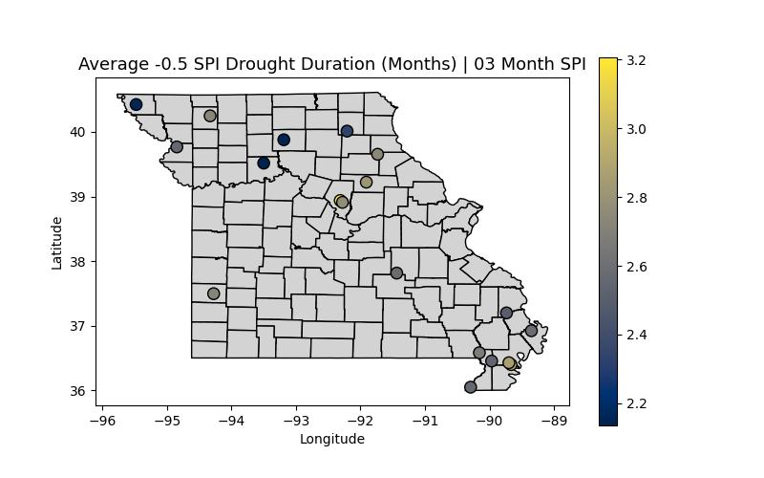

Low impact drought appears on average to last 2-3 months across the state. Notably, the northern half of the state appears to have slightly shorter droughts overall.

#### Frequency:

Low-impact drought occurs between 25 and 35% of the time in Missouri. Eastern portions of the state tend to be in drought more often than western portions of the state.

The most extreme drought durations in the short term look to be in the 6-10 month range, although notably the bootheel had a station which was in drought for over a year! The bootheel has many interesting outliers through the years, which are detailed in the microclimates section of this paper.

#### Onset Seasonality:

Onset seasonality shows a fascinating picture. Low-impact drought tends to start far and away the most often in winter. There are some stations where drought begins a bit earlier or later. This is the most common season for drought to begin though, not the only season. Traditionally you would think that summer is when drought onset is most common, but alas, it is winter.

#### Relief Seasonality:

Drought relief strangely enough also has a similar seasonal signal to onset, which is for the plurality of stations winter, with most of the others being in a transitional season. This makes sense, as the most aggressive weather pattern flips tend to occur this time of year, so if it has been wet, a shift to dry would most likely occur in the winter, likewise if it has been dry, a pattern flip is most likely in the winter as well, when the jet stream is most active.

### High-Impact:

#### Average Duration:

High-impact drought appears to be fairly short duration on average, 1-2 months. The most notable extreme is the station near the Dent/Crawford county line which shows notably longer high-impact drought duration than the other stations.

High impact drought tends to occur 9-13% of the time in the state. The central portion of the state seems to get it least, with the northwestern portion having high-impact drought more often, and Mississippi county having notably higher high-impact drought frequency than the stations surrounding it. This will be the focus of the case study later in the paper.

Short-term high-impact drought lasting 6 months is crazy! But it happened at two stations, one in Dunklin county, and one in Crawford county. Every station had at least 3 months of high impact drought at some point in the period. Again though, these are extremes, not the usual, this is to depict potential worst case scenarios in the future.

#### Onset Seasonality:

Higher impact drought events have a less clear seasonal signal, but in the bootheel in particular, it seems that many high impact drought events begin in the spring. Regardless, high impact drought can occur any time of year, but it does seem like spring, especially in the bootheel is the most common season.

#### Relief Seasonality:

Relief from high-impact drought doesn’t have a clear dominant seasonal signal, likely because extreme events help dig out of high-impact drought. Extreme events can happen any time of year, but are most common in the summer and least common in the winter.

## Medium-Term Drought:

### Low-Impact:

Low impact drought at the 6-month time scale tends to last 3-5 months. These drought events tend to last longer in southeastern Missouri than northwestern Missouri.

#### Frequency:

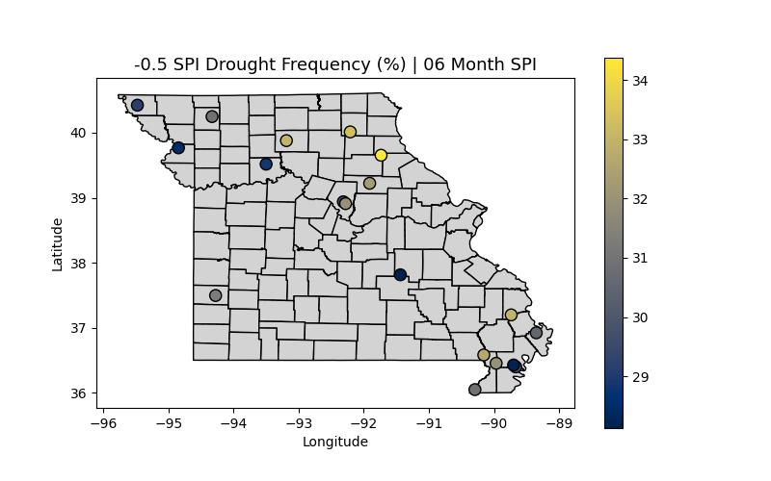

Low-impact drought tends to occur 28-35% of the time across the state. Drought is most often occurring in the northeastern portions of Missouri.

The most extreme low-impact drought durations vary somewhat wildly across the state. Notably the Barton county station once had 22 consecutive months of high-impact drought, which is crazy! This will be the subject of the medium term case study.

#### Onset Seasonality:

6-month drought has nowhere near the signal of 3-month drought for winter drought onset, this time it seems as though winter and spring are when drought onset is most common across the state. The farther north you go, the earlier in the year drought onset tends to be.

#### Relief Seasonality:

Drought relief happened most frequently in the winter and spring during wet patterns, and most often occurred in the spring by some margin both in spatial coverage and the actual numbers at each station.

### High-Impact:

High-impact drought tends to last 2-3 months, although it can last longer at some stations on average. Notably western Missouri tends to have longer lasting high-impact drought than eastern Missouri.

The bootheel is where my eye is immediately drawn. 13% of the time a Pemiscot county station is in high-impact drought, that’s quite often. 9-13% of the time other stations in the state are in high-impact drought.

Crawford county once again jumps out with an 11 consecutive month high-impact drought. Most stations had their most extreme drought last 5-9 months, but Crawford county notably had a substantially longer duration of high-impact drought.

#### Onset Seasonality:

High-impact drought doesn’t have a clear seasonal signal across many stations, but it seems that perhaps the farther east you go, the later in the year high-impact drought onset begins.

#### Relief Seasonality:

High-impact drought relief is most common in the spring, but can happen any season, especially one like summer, which favors small-scale extreme rainfall events, which is captured on the Boone county station.

## Long-Term Drought:

### Low-Impact:

Long-term drought tends to last 4-6 months on average, with Barton county being a notable outlier with an average drought duration of nearly 11 months!

Stations were in drought ~20-35% of the time. Northwestern and southeastern Missouri getting in on drought most often, while central Missouri is in drought less often.

The bare minimum longest duration of low-impact drought at this scale is a year, with notably the Gentry county station being in drought for over two years!

#### Onset Seasonality:

Long term drought tends to begin during transitional seasons or the summer, when a pattern flip occurs.

#### Relief Seasonality:

Drought relief seasonality does not have a strong signal toward any particular season.

### High-Impact:

High-impact drought duration tells a less extreme variant of the same story. 2-5 months on average across the state, with Barton county again being a notable outlier at 8 months!

High-impact drought tended to happen 9-12% of the time in most portions of the state, with a frequency as low as 4% being recorded in Knox county, where high impact drought is significantly less common than the rest of the state.

From a fourth of a year to over a year, the variability in the longest high-impact drought across stations is wide! Generally, it looks like the farther west you go, the higher risk there is for a long-duration high impact drought.

#### Onset Seasonality:

High-impact drought onset doesn’t have a particularly strong signal across most of the state, except for the Bootheel. It is categorically true by some margin in the data that most high-impact drought events down there begin in the fall.

#### Relief Seasonality:

High-impact drought relief tends to be most common in the fall, especially in northwestern Missouri.

## Microclimates:

Microclimates are exactly what they sound like, the climate of a small area/region. In this section, we will investigate how Missouri mesonet stations that are small distances away from each other vary using different metrics. How similar are their rainfall totals? Do they correlate well? How big of a difference can 5 miles really make?

### Boone County:

The most obvious case of two stations close to one another are the two in Boone County that were used in this analysis. The one at Sanborn field, and the one at South Farm. These stations are approximately 3 miles apart, so intuitively the thought is that these stations will have very similar data.

#### 1 Month SPI Time Series:

The first way to evaluate this is to look at a time series. Looking at the monthly data over the entire period of record, are Sanborn and South Farm similar?

The answer is yes, these two stations are very similar, but, especially when it comes to extremes, it is obvious that there are small periods of time where these stations vary more substantially. The most notable difference between the two stations occurred in August of 2007. Sanborn field had an SPI of -0.74, while South Farm had an SPI of -1.95. That means Sanborn had a month that was abnormally dry, or D0. While South Farm had a month that was extremely dry, or D3. This variance all comes down to one day. August 24th, 2007. Sanborn Field picked up 1.97” of rain that day, while South Farm only picked up 0.53”. What a difference 3 miles makes!

#### Correlation:

Correlation is “the interdependence of variable quantities” (Oxford Languages), or to put it in layman's terms, it is the similarity between two sets of data. Or to put it another way, if one data set is used to predict another dataset, how accurate would it be? Correlation can be measured through a correlation coefficient. Think of this as a “correlation score”. This score is measured from -1 to +1. If the correlation between two sets of data is +1, that means the data in both sets is exactly the same. If the correlation between two sets of data is -1, that means they are exactly the opposite, ex. (-16 -> 16). A correlation of 0 means that two datasets have no relationship at all. In this case, we are curious about how related two sets of data are, so, what is the correlation coefficient of Sanborn Field and South Farms? This is a nuanced question, for the purposes of this paper we will use 03M SPI, as it is the most useful of the datasets for agriculture purposes.

The correlation between Sanborn Field and South Farms is ***0.97***. This is *incredibly* high, and validates our intuition that these two stations are largely similar, and from a climatological perspective are virtually the same. Still, though, as was demonstrated in the time series, while over a 24 year period of record, the extremes are largely “smoothed” out, a time series shows that if you isolate portions of the record, these two stations can vary significantly.

#### Variance:

Variance tells us another piece of the puzzle. How consistent is the data at these stations? Are they all over the place, or are they pretty steady? Variance can help us determine this. This is exactly how SPI is calculated, meaning that we can use it to determine the typical ranges of both stations. From there, we can find out which station has a larger range, and therefore, more variable weather in this climatological period.

An annual period seems most intuitive for measuring the variance between two stations, and therefore 12M SPI is being used here. A seasonal analysis will follow.

|  |  |  |  |
| --- | --- | --- | --- |
|  | Abnormally Wet | Abnormally Dry | Variance |
| Sanborn Field | 43.07” | 34.65” | 8.42” |
| South Farms | 42.85” | 35.09” | 7.76” |

Using a very rudimentary but useful analysis, it appears that Sanborn Field and South Farms have a similar level of variance within their “normal” range; however, South Farms has a lower normal range, meaning that the climate is a little more consistent.

#### Correlation and Variance:

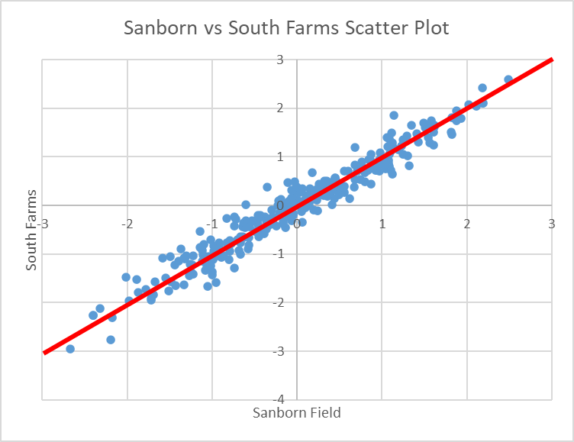

One of the best ways to visualize both correlation and variance is to use a scatter plot. A scatter plot is simply a graph with points that compare two values. In this case the X Axis is Sanborn Field 3M SPI, and the Y Axis is the corresponding South Farms 3M SPI at the same time.

### Bootheel:

Another place that warrants further investigation from a micro-climate standpoint is the Missouri Bootheel. There are 7 stations with the full 24 year period of record on them that go down there! So, let’s analyze the correlation, variance, and put them together

#### Correlation:

Correlation, as has been established, essentially measures how similar two sets of data are, in this case the drought data from two stations. Below is a “correlation matrix”, a fancy term for a bunch of boxes telling you how similar two stations are. For example, want to see how similar Charleston and Portageville are, you can look at their respective rows and columns and find the value you’re looking for. Portageville and Hayward appear the most similar of the stations in the matrix, with a 0.95 correlation, which is almost as close as the Boone county stations. The least related of the stations appears to be the Charleston and Cardwell stations, with a correlation of 0.71. To be clear, 0.71 still means these stations are closely related, but they are the least closely related of the stations in the matrix.



#### Variance:

We took the same approach for variance here as before. We are trying to see what range of rainfall is “normal” for a given station. The larger the range, the larger the variance. Between the stations it is fairly similar. The extremes are Clarkton with 8.15” and Glennonville with 9.62”. That’s an 18% increase between Clarkton and Glennonville, showing the variance of the variance, or the consistency of consistency.

|  |  |  |  |
| --- | --- | --- | --- |
|  | Abnormally Wet | Abnormally Dry | Variance |
| Clarkton | 49.74” | 41.59” | 8.15” |
| Charleston | 50.15” | 41.78” | 8.37” |
| Cardwell | 51.54” | 42.65” | 8.89” |
| Portageville | 52.81” | 43.83” | 8.98” |
| Hayward | 52.07” | 43.59” | 8.48” |
| Glennonville | 48.84” | 39.22” | 9.62” |
| Delta | 51.85” | 42.38” | 9.47” |

# Missouri Mesonet Drought Tracking:

Below is a step-by-step guide to tracking drought using the drought chart provided in Appendix B.

To begin, find out which Mesonet station in the study is closest to you. You’ll want to navigate to <http://agebb.missouri.edu/weather/stations/>, where you’ll find a map of the stations available. Once you find a station you are satisfied with, check any of the drought charts in Appendix B to ensure that the station is on the list. Assuming it is, you are ready to move to the next step.

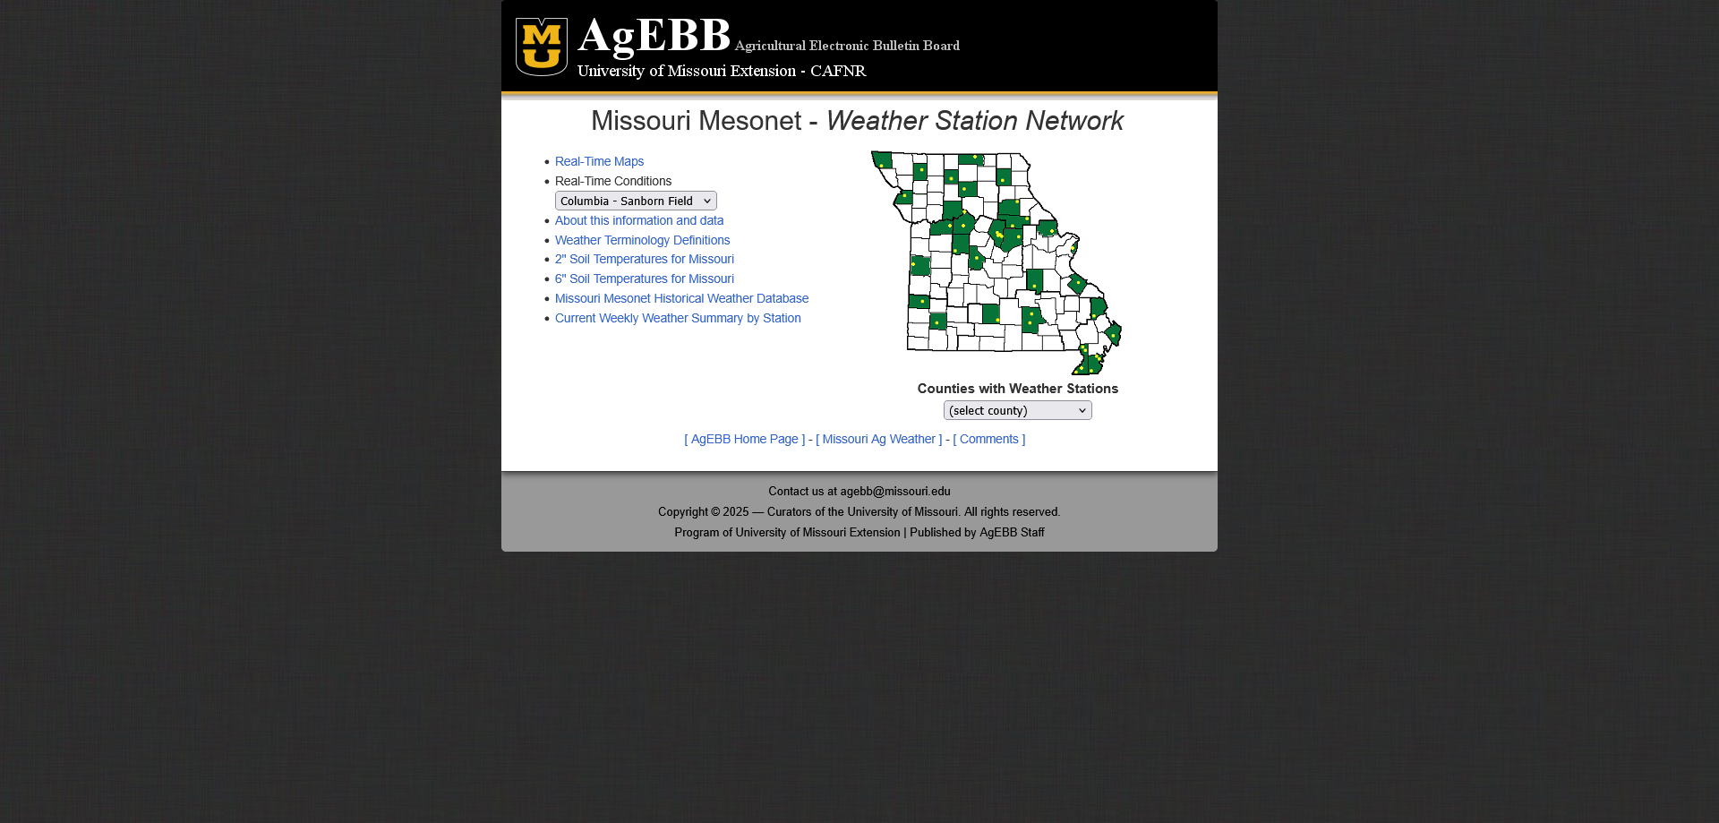

The next step is determining which season you would like to evaluate drought for, most people will want the most recent season, but here are the months evaluated for the different seasons:

Spring: March, April, May

Summer: June, July, August

Autumn: September, October, November

Winter: December, January, February

Once your season is determined, pull up the associated drought chart. Now comes the fun part, which is getting the data.

To begin, on the page you first navigated to when finding your station, click the “Missouri Mesonet Historical Weather Database”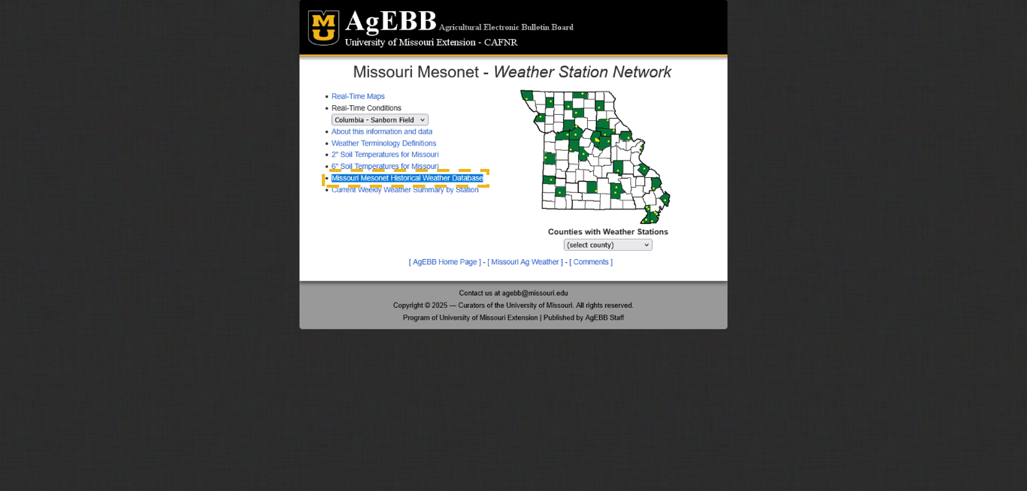

You should then find yourself on the following web page:

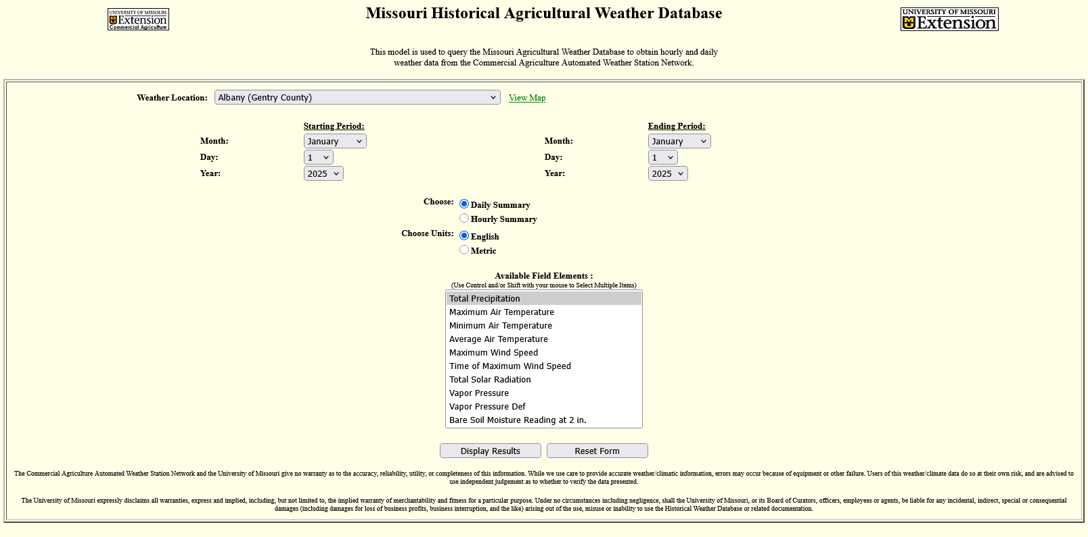

From here, there are two ways you can select the station you’re looking for. The first is to click on the dropdown menu next to the text “Weather Location:”, and then select the station you want.

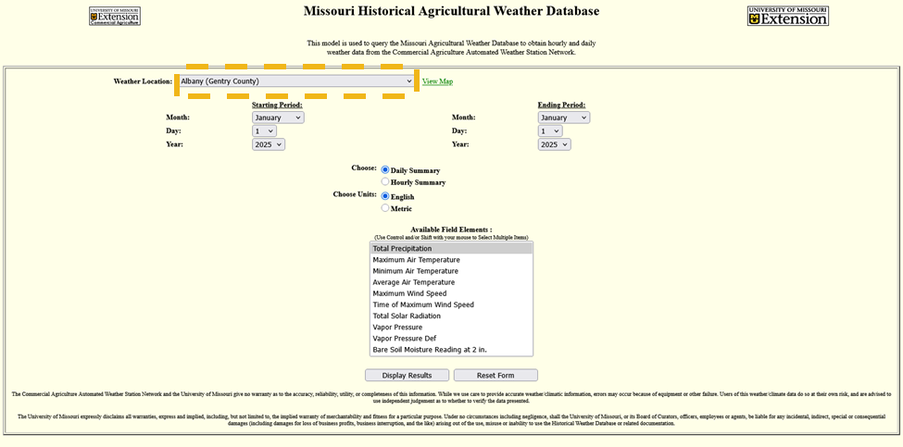

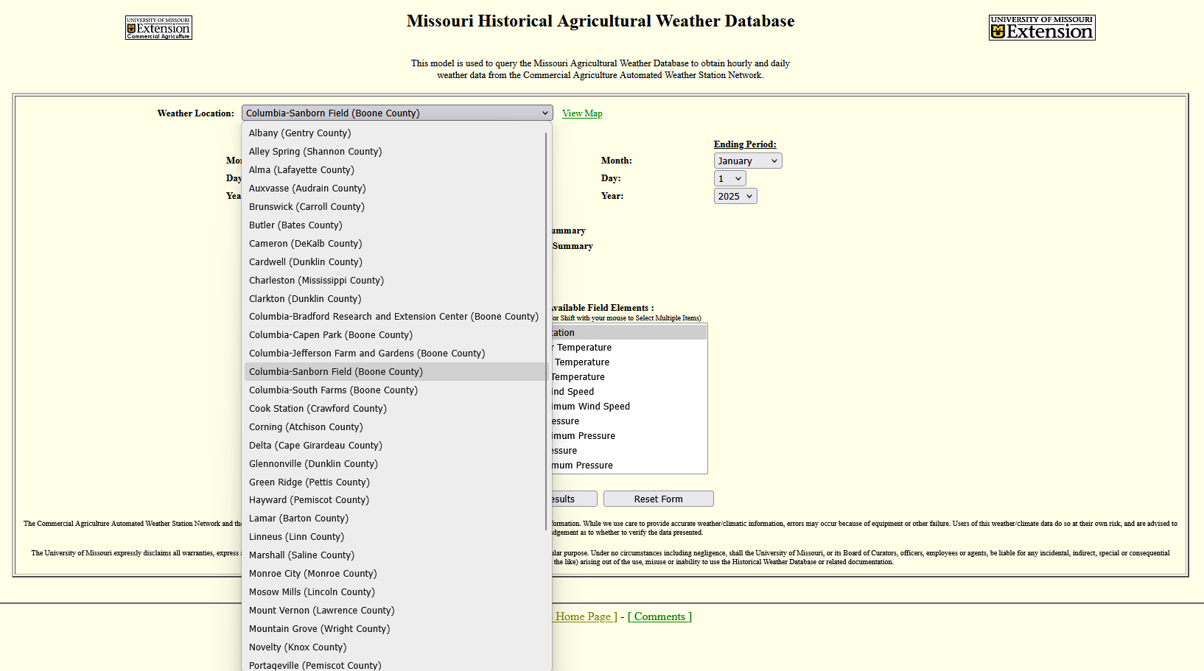

The other way you can select a station is to click the “view map” button next to the dropdown menu, and click on the location you want, the map will look like this: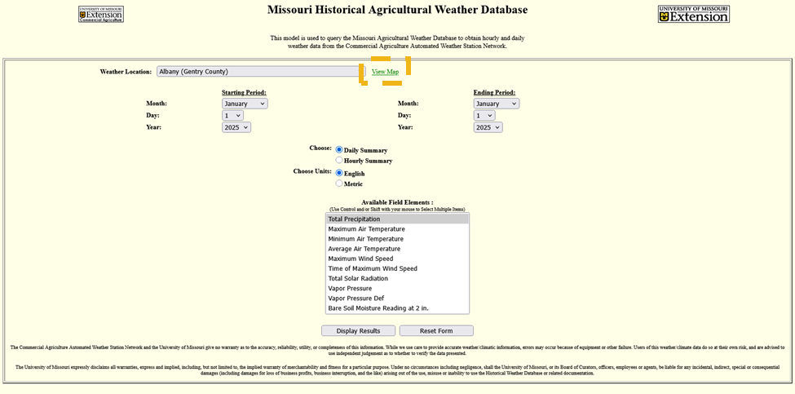

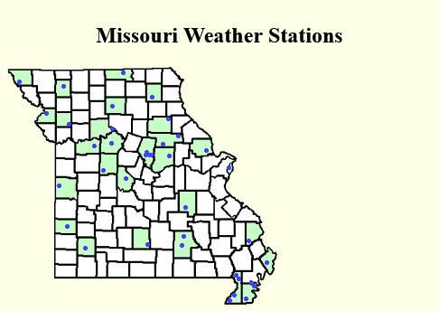

For this example, I will use the location “Columbia-Sanborn Field (Boone County)”

Our attention then shifts to the period we are interested in. In this case we will want our period to be the first day of the first month of a season, to the last day of the last month of a season. Use the dropdown menus for the starting and ending period to select what you want. In this case, I will evaluate Spring 2025 drought, so I will select March 1st 2025 to May 31st 2025.

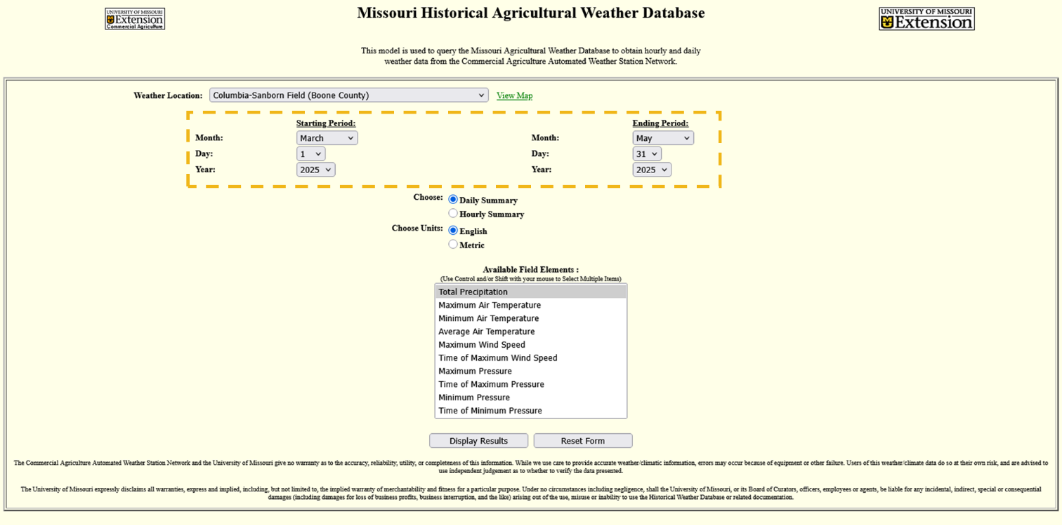

After that, we want to make sure our data is formatted correctly. We want to leave the Choose and Choose Units options untouched; they are what we want by default.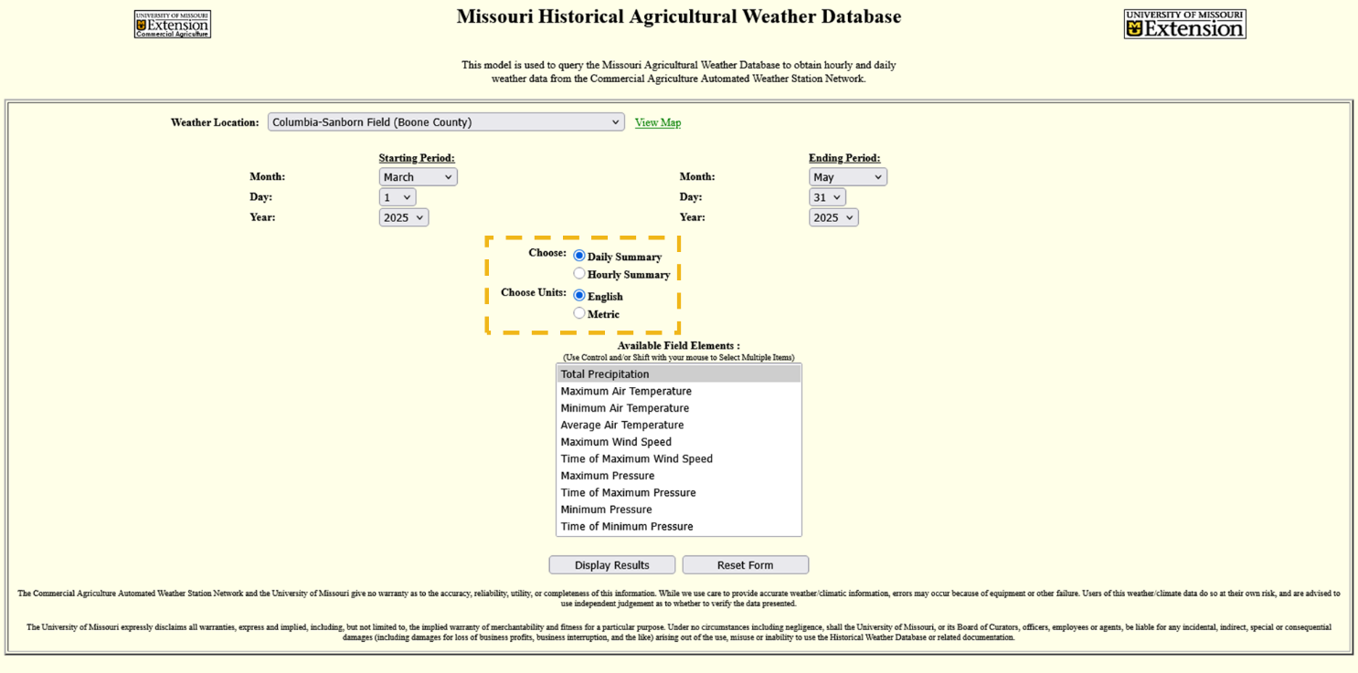

Finally, and for us conveniently, we need to select the variables we are interested in, in this case “Total Precipitation” is what we want, and it is already selected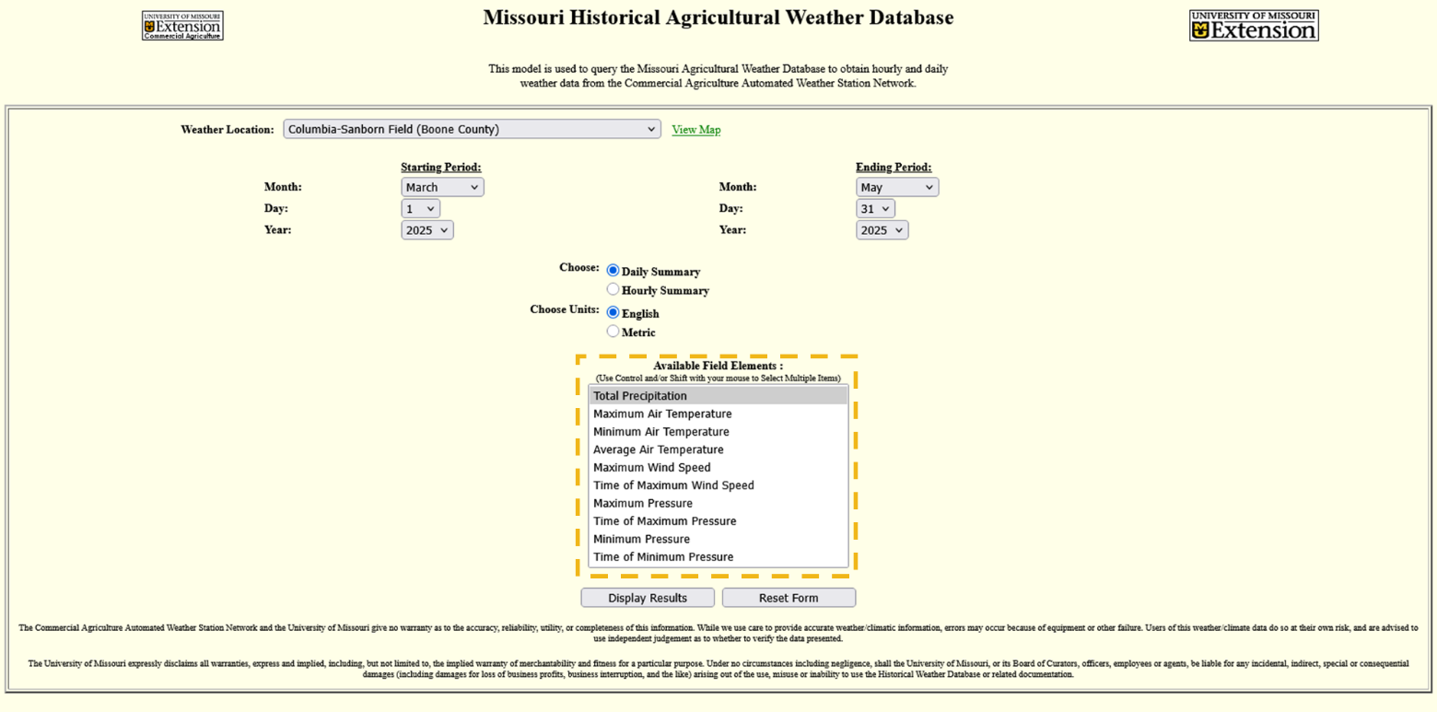

Now click the “Display results button”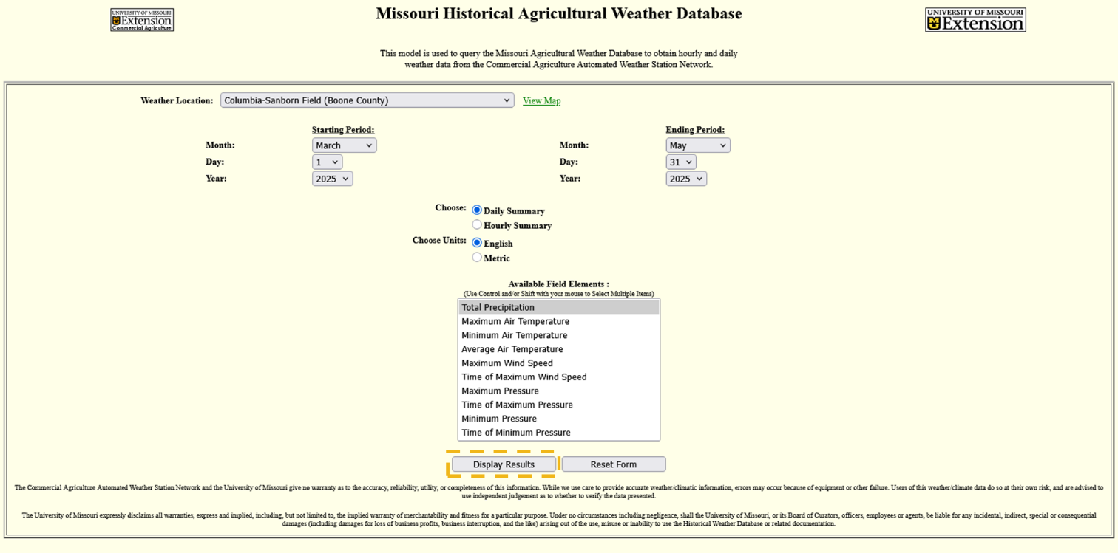

You will be presented with a long list of data, the total precipitation in inches for each day we asked for. The good news is that we don’t need to go through every single day and add everything together, we just need to scroll to the bottom of the page and get the “Total:” value.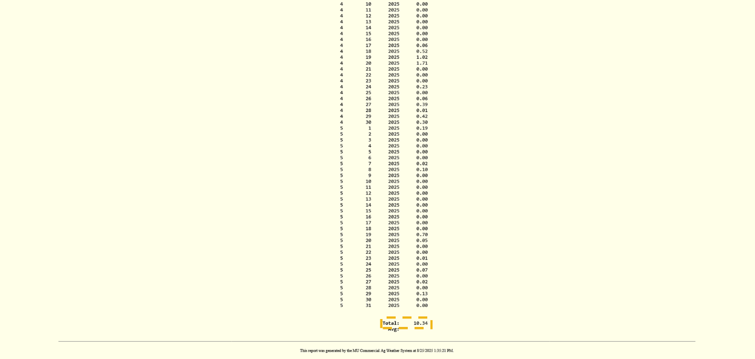

Now for the part we’ve been waiting for, let’s bring out the drought chart. In this example, I will be using the spring one, but they are all used in the same way. You can find them in Appendix B.

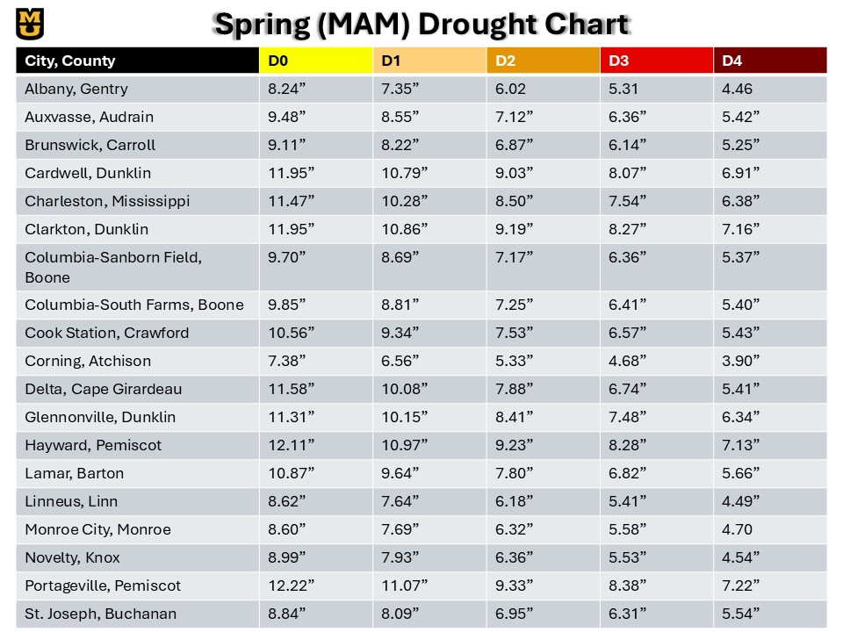

The drought chart has the stations listed in the first column, followed by corresponding precipitation values for D0-D4 drought. The rule of thumb is that we will work from D0 to D4, and see if our precipitation value is ***less than OR equal to*** the one needed for the drought category we are assessing.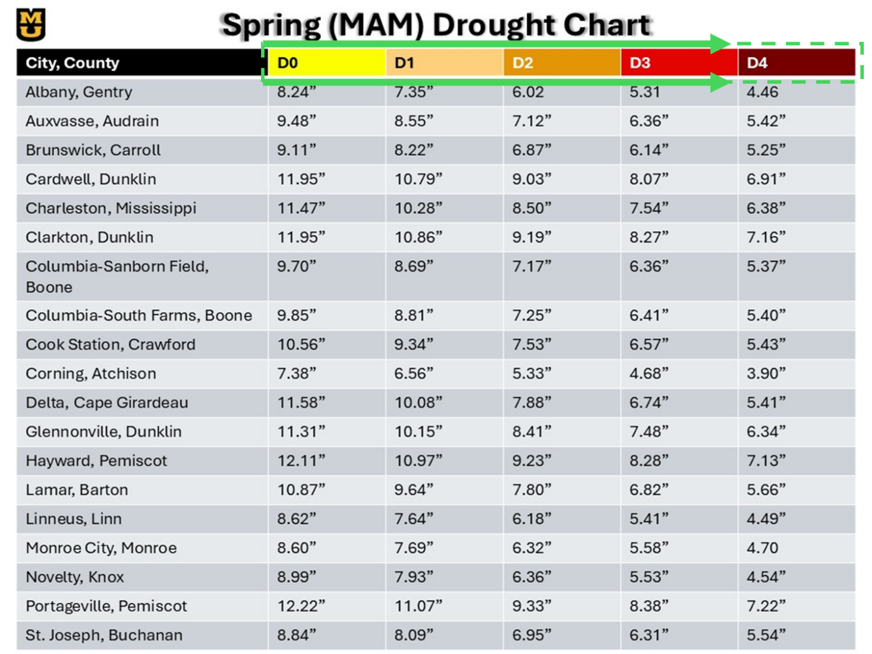

At Sanborn Field for Spring of 2025. Our value is 10.34”, and D0 is 9.70”, therefore, using this method, we were not in a drought this spring. Let’s say the value was hypothetically, 5.41”, how would that work? We would work our way inwards. 5.41” is less than 9.70”, so we are in at least D0. What about D1? D1 is 8.69”, which is higher than 5.41”, so we are in at least D1. D2 is 7.17”, and D3 is 6.36”, so we are in at least D3. D4 is 5.37”, while 5.41” is close, it is **greater than** the D4 threshold, and therefore we are NOT in D4.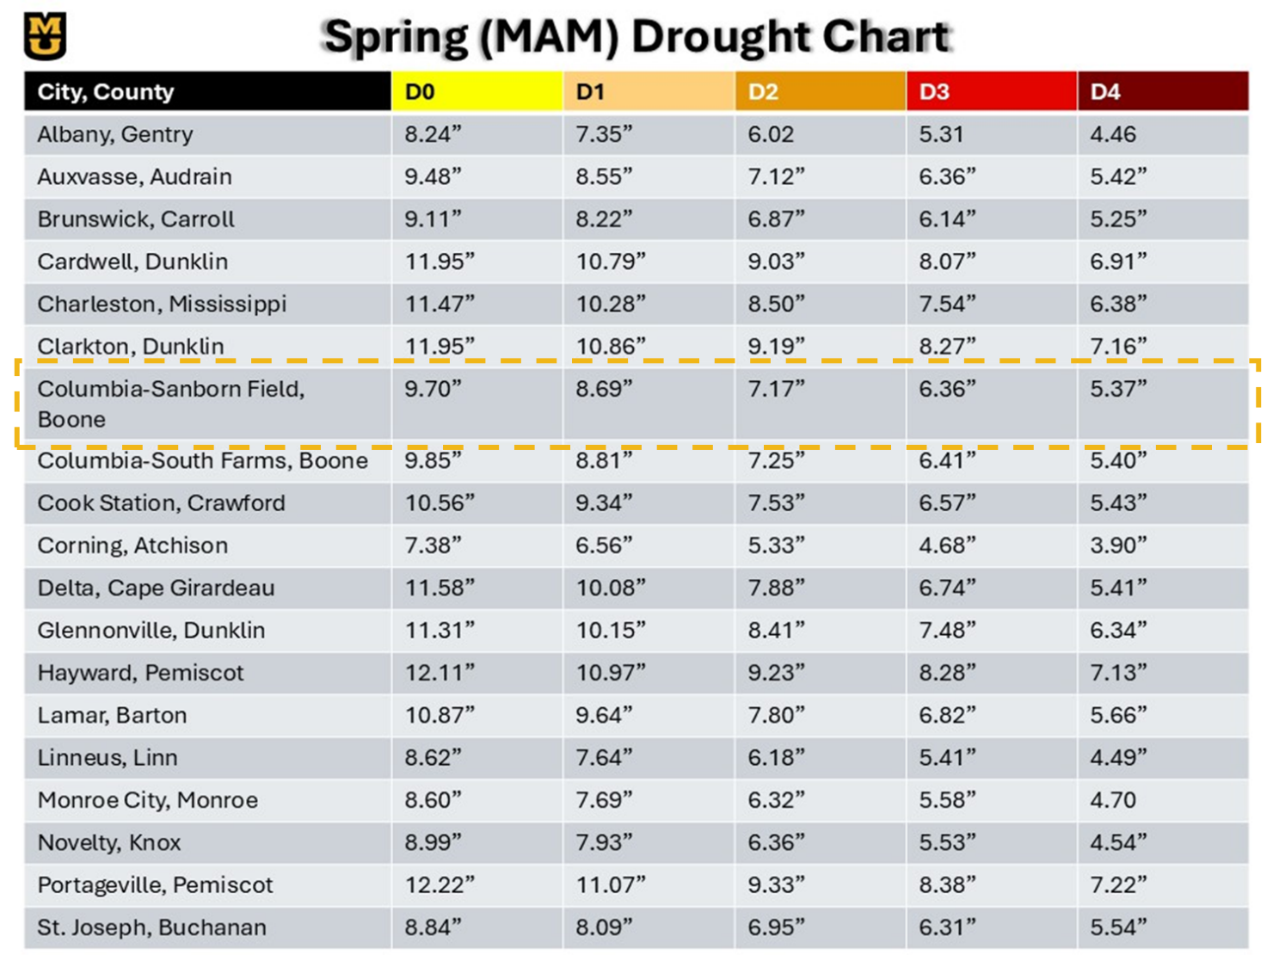

# Conclusions:

## Key Findings:

## Implications for Policy Makers and Stakeholders:

## For Future Research:

Future research can take a few directions:

The first is using Missouri Mesonet data to evaluate the accuracy of radar estimated rainfall at various points in Missouri.

We can also use this drought climatology and see if using it with S2S models allows for skillful predictability.

Finally, additional research can be done on micro-climates using stations in close proximity to each other.

# Appendix A:

***Albany, Gentry County, MO***

Good for use: **Yes**

Changes: **None**

***Alley Spring, Shannon County, MO***

Good for use: **No**

Reasons: **The dataset only spans from 2005-2016, and months of data within that period are missing**

***Alma, Lafayette County, MO***

Good for use: **No**

Reasons: **The dataset began in 2019**

***Auxvasse, Audrain County, MO***

Good for use: **Yes**

Changes: **None**

***Brunswick, Carroll County, MO***

Good for use: **Yes**

Reasons: **Data spans from 2000 to 2024, however, a month and a half of data is missing from 2019, spanning from 05/26/2019 to 07/04/2019**

**Reconstructed Data:**

**Station Used: Keytesville, MO (GHCN, CoCoRAHS, MOFSA) (US1MOFSA041, MOFSA041, MOFSA041) (10.4 Miles Away), National Water Prediction Center Precipitation Estimate (Multi-Sensor Data)**

**5 26 20****19 0.08**

**5 27 2019 0.00**

**5 28 2019 0.06**

**5 29 2019 0.42**

**5 30 2019 0.03**

**5 31 2019 0.01**

**6 1 2019 0.00**

**6 2 2019 0.00**

**6 3 2019 0.00**

**6 4 2019 0.00**

**6 5 2019 0.00**

**6 6 2019 0.73**

**6 7 2019 0.00**

**6 8 2019 0.00**

**6 9 2019 0.00**

**6 10 2019 0.00**

**6 11 2019 0.00**

**6 12 2019 0.00**

**6 13 2019 0.49**

**6 14 2019 0.00**

**6 15 2019 0.85**

**6 16 2019 0.11**

**6 17 2019 0.25**

**6 18 2019 0.00**

**6 19 2019 0.28**

**6 20 2019 0.00**

**6 21 2019 0.00**

**6 22 2019 2.11**

**6 23 2019 1.88**

**6 24 2019 0.19**

**6 25 2019 0.00**

**6 26 2019 0.00**

**6 27 2019 0.00**

**6 28 2019 0.00**

**6 29 2019 0.00**

**6 30 2019 0.00**

**7 1 2019 0.00**

**7 2 2019 0.00**

**7 3 2019 0.00**

**7 4 2019 0.00**

***Butler, Bates County, MO***

Good for use: **No**

Reasons: **The dataset began in 2015**

***Cameron, DeKalb County, MO***

Good for use: **No**

Reasons: **The dataset ended in 2004**

***Cardwell, Dunklin County, MO***

Good for use: **Yes**

Changes: **None**

***Charleston, Mississippi County, MO***

Good for use: **Yes**

Changes: **None**

***Clarkton, Dunklin County, MO***

Good for use: **Yes**

Reasons: **While data began in 2000, it was August of 2000, so there was a lot of data that needed reconstruction.**

**Reconstructed Data:**

**Stations Used: Malden, MO (GHCN, COOP, NWSLI) (USC00235207, 235207, MLDM7) (7.3 Miles Away), Saint Francis, AR (GHCN, COOP, NWSLI) (USC00036380, 036380, SFRA4) (9.9 Miles Away)**

**1 1 2000 0.00**

**1 2 2000 0.00**

**1 3 2000 4.26**

**1 4 2000 2.00**

**1 5 2000 0.01**

**1 6 2000 0.01**

**1 7 2000 0.00**

**1 8 2000 0.00**

**1 9 2000 0.00**

**1 10 2000 0.00**

**1 11 2000 0.00**

**1 12 2000 0.00**

**1 13 2000 0.01**

**1 14 2000 0.00**

**1 15 2000 0.00**

**1 16 2000 0.00**

**1 17 2000 0.00**

**1 18 2000 0.01**

**1 19 2000 0.00**

**1 20 2000 0.00**

**1 21 2000 0.00**

**1 22 2000 0.00**

**1 23 2000 0.10**

**1 24 2000 0.30**

**1 25 2000 0.00**

**1 26 2000 0.00**

**1 27 2000 0.00**

**1 28 2000 0.00**

**1 29 2000 1.40**

**1 30 2000 0.00**

**1 31 2000 0.00**

**2 1 2000 0.00**

**2 2 2000 0.00**

**2 3 2000 0.00**

**2 4 2000 0.00**

**2 5 2000 0.00**

**2 6 2000 0.00**

**2 7 2000 0.00**

**2 8 2000 0.00**

**2 9 2000 0.00**

**2 10 2000 0.00**

**2 11 2000 0.00**

**2 12 2000 0.32**

**2 13 2000 0.08**

**2 14 2000 0.05**

**2 15 2000 0.00**

**2 16 2000 0.00**

**2 17 2000 0.15**

**2 18 2000 2.20**

**2 19 2000 0.18**

**2 20 2000 0.00**

**2 21 2000 0.00**

**2 22 2000 0.00**

**2 23 2000 0.00**

**2 24 2000 0.30**

**2 25 2000 0.00**

**2 26 2000 0.11**

**2 27 2000 0.75**

**2 28 2000 0.00**

**2 29 2000 0.00**

**3 1 2000 0.00**

**3 2 2000 0.00**

**3 3 2000 0.17**

**3 4 2000 0.24**

**3 5 2000 0.00**

**3 6 2000 0.00**

**3 7 2000 0.00**

**3 8 2000 0.00**

**3 9 2000 0.00**

**3 10 2000 0.00**

**3 11 2000 0.08**

**3 12 2000 0.00**

**3 13 2000 0.00**

**3 14 2000 0.00**

**3 15 2000 0.00**

**3 16 2000 1.52**

**3 17 2000 0.08**

**3 18 2000 0.04**

**3 19 2000 0.46**

**3 20 2000 0.50**

**3 21 2000 0.02**

**3 22 2000 0.00**

**3 23 2000 0.00**

**3 24 2000 0.00**

**3 25 2000 0.00**

**3 26 2000 0.01**

**3 27 2000 0.05**

**3 28 2000 0.00**

**3 29 2000 0.01**

**3 30 2000 0.66**

**3 31 2000 3.84**

**4 1 2000 0.00**

**4 2 2000 0.11**

**4 3 2000 0.02**

**4 4 2000 0.00**

**4 5 2000 0.00**

**4 6 2000 0.00**

**4 7 2000 0.00**

**4 8 2000 0.14**

**4 9 2000 0.00**

**4 10 2000 0.00**

**4 11 2000 0.15**

**4 12 2000 0.20**

**4 13 2000 0.00**

**4 14 2000 0.00**

**4 15 2000 0.00**

**4 16 2000 0.00**

**4 17 2000 0.21**

**4 18 2000 0.00**

**4 19 2000 0.00**

**4 20 2000 0.00**

**4 21 2000 0.00**

**4 22 2000 0.00**

**4 23 2000 0.00**

**4 24 2000 0.22**

**4 25 2000 0.48**

**4 26 2000 0.00**

**4 27 2000 0.00**

**4 28 2000 0.00**

**4 29 2000 0.00**

**4 30 2000 0.00**

**5 1 2000 0.00**

**5 2 2000 0.00**

**5 3 2000 0.73**

**5 4 2000 0.08**

**5 5 2000 0.07**

**5 6 2000 0.20**

**5 7 2000 0.03**

**5 8 2000 0.00**

**5 9 2000 0.00**

**5 10 2000 1.12**

**5 11 2000 0.00**

**5 12 2000 0.00**

**5 13 2000 0.01**

**5 14 2000 0.00**

**5 15 2000 0.00**

**5 16 2000 0.00**

**5 17 2000 0.00**

**5 18 2000 0.00**

**5 19 2000 0.81**

**5 20 2000 0.00**

**5 21 2000 0.00**

**5 22 2000 0.00**

**5 23 2000 0.03**

**5 24 2000 0.00**

**5 25 2000 2.02**

**5 26 2000 0.36**

**5 27 2000 2.12**

**5 28 2000 1.10**

**5 29 2000 0.00**

**5 30 2000 0.00**

**5 31 2000 0.00**

**6 1 2000 0.00**

**6 2 2000 0.00**

**6 3 2000 0.00**

**6 4 2000 0.00**

**6 5 2000 0.00**

**6 6 2000 0.00**

**6 7 2000 0.00**

**6 8 2000 0.00**

**6 9 2000 0.00**

**6 10 2000 0.00**

**6 11 2000 0.01**

**6 12 2000 0.00**

**6 13 2000 0.00**

**6 14 2000 0.00**

**6 15 2000 0.38**

**6 16 2000 0.00**

**6 17 2000 0.00**

**6 18 2000 0.37**

**6 19 2000 0.57**

**6 20 2000 0.55**

**6 21 2000 0.57**

**6 22 2000 0.09**

**6 23 2000 0.00**

**6 24 2000 0.00**

**6 25 2000 0.00**

**6 26 2000 0.02**

**6 27 2000 0.65**

**6 28 2000 0.00**

**6 29 2000 0.08**

**6 30 2000 0.00**

**7 1 2000 0.01**

**7 2 2000 0.00**

**7 3 2000 0.00**

**7 4 2000 0.06**

**7 5 2000 0.00**

**7 6 2000 0.00**

**7 7 2000 0.00**

**7 8 2000 0.00**

**7 9 2000 0.00**

**7 10 2000 0.00**

**7 11 2000 0.00**

**7 12 2000 0.00**

**7 13 2000 0.00**

**7 14 2000 0.00**

**7 15 2000 0.00**

**7 16 2000 0.01**

**7 17 2000 0.00**

**7 18 2000 0.00**

**7 19 2000 0.12**

**7 20 2000 0.00**

**7 21 2000 0.30**

**7 22 2000 0.00**

**7 23 2000 0.01**

**7 24 2000 0.00**

**7 25 2000 0.00**

**7 26 2000 0.00**

**7 27 2000 0.00**

**7 28 2000 0.00**

**7 29 2000 0.27**

**7 30 2000 0.91**

**7 31 2000 0.00**

***Columbia-Bradford Research and Extension Center, Boone County, MO***

Good for use: **No**

Reasons: **The dataset began in 2009**

***Columbia-Capen Park, Boone County, MO***

Good for use: **No**

Reasons: **The dataset began in 2011**

***Columbia-Jefferson Farm and Gardens, Boone County, MO***

Good for use: **No**

Reasons: **The dataset began in 2008**

***Columbia-Sanborn Field, Boone County, MO***

Good for use: **Yes**

Changes: **None**

***Columbia-South Farms, Boone County, MO***

Good for use: **Yes**

Changes: **None**

***Cook Station, Crawford County, MO***

Good for use: **Yes**

Changes: **None**

***Corning, Atchison County, MO***

Good for use: **Yes**

Reasons: **Data spans from 2000 to 2024, however, data is missing from 2012, spanning from 07/26/2012 to 08/05/2012, so reconstruction was needed**

**Reconstructed Data:**

**Stations Used: Fairfax, MO (COOP, NWSLI) (232731, FFXM7) (7.1 Miles Away), Falls City, NE (Barada, NE) (GHCN, CoCoRaHS) (US10rich006, 0rich006) (6.8 Miles Away)**

**7 26 2012 1.36**

**7 27 2012 0.05**

**7 28 2012 0.00**

**7 29 2012 0.00**

**7 30 2012 0.00**

**7 31 2012 0.01**

**8 1 2012 0.00**

**8 2 2012 0.05**

**8 3 2012 0.05**

**8 4 2012 0.25**

**8 5 2012 0.26**

***Delta, Cape Girardeau County, MO***

Good for use: **Yes**

Changes: **None**

***Glennonville, Dunklin County, MO***

Good for use: **Yes**

Changes: **None**

***Green Ridge, Pettis County, MO***

Good for use: **No**

Reasons: **The dataset began in 2004**

***Hayward, Pemiscot County, MO***

Good for use: **Yes**

Reasons: **The dataset began on May 31st, 2000, so reconstruction was needed**

**Reconstructed Data:**

**Stations Used: Portageville, MO (MO Mesonet) (mo6804) (2.9 Miles Away)**

**1 1 2000 0.00**

**1 2 2000 2.35**

**1 3 2000 1.60**

**1 4 2000 0.02**

**1 5 2000 0.00**

**1 6 2000 0.00**

**1 7 2000 0.00**

**1 8 2000 0.00**

**1 9 2000 0.00**

**1 10 2000 0.00**

**1 11 2000 0.00**

**1 12 2000 0.22**

**1 13 2000 0.00**

**1 14 2000 0.00**

**1 15 2000 0.00**

**1 16 2000 0.00**

**1 17 2000 0.08**

**1 18 2000 0.00**

**1 19 2000 0.00**

**1 20 2000 0.00**

**1 21 2000 0.00**

**1 22 2000 0.30**

**1 23 2000 0.00**

**1 24 2000 0.00**

**1 25 2000 0.00**

**1 26 2000 0.00**

**1 27 2000 0.00**

**1 28 2000 0.00**

**1 29 2000 0.21**

**1 30 2000 0.00**

**1 31 2000 0.00**

**2 1 2000 0.00**

**2 2 2000 0.00**

**2 3 2000 0.00**

**2 4 2000 0.00**

**2 5 2000 0.00**

**2 6 2000 0.00**

**2 7 2000 0.00**

**2 8 2000 0.00**

**2 9 2000 0.00**

**2 10 2000 0.00**

**2 11 2000 0.17**

**2 12 2000 0.04**

**2 13 2000 0.42**

**2 14 2000 0.00**

**2 15 2000 0.00**

**2 16 2000 0.00**

**2 17 2000 1.70**

**2 18 2000 0.66**

**2 19 2000 0.00**

**2 20 2000 0.00**

**2 21 2000 0.00**

**2 22 2000 0.00**

**2 23 2000 0.45**

**2 24 2000 0.06**

**2 25 2000 0.00**

**2 26 2000 1.56**

**2 27 2000 0.00**

**2 28 2000 0.00**

**2 29 2000 0.00**

**3 1 2000 0.00**

**3 2 2000 0.00**

**3 3 2000 0.43**

**3 4 2000 0.00**

**3 5 2000 0.00**

**3 6 2000 0.00**

**3 7 2000 0.00**

**3 8 2000 0.00**

**3 9 2000 0.00**

**3 10 2000 0.00**

**3 11 2000 0.08**

**3 12 2000 0.00**

**3 13 2000 0.00**

**3 14 2000 0.00**

**3 15 2000 0.28**

**3 16 2000 1.91**

**3 17 2000 0.00**

**3 18 2000 0.39**

**3 19 2000 1.29**

**3 20 2000 0.02**

**3 21 2000 0.00**

**3 22 2000 0.00**

**3 23 2000 0.00**

**3 24 2000 0.00**

**3 25 2000 0.00**

**3 26 2000 0.02**

**3 27 2000 0.04**

**3 28 2000 0.00**

**3 29 2000 0.39**

**3 30 2000 0.00**

**3 31 2000 0.00**

**4 1 2000 0.07**

**4 2 2000 0.06**

**4 3 2000 0.01**

**4 4 2000 0.00**

**4 5 2000 0.00**

**4 6 2000 0.00**

**4 7 2000 0.02**

**4 8 2000 0.00**

**4 9 2000 0.00**

**4 10 2000 0.00**

**4 11 2000 0.92**

**4 12 2000 0.00**

**4 13 2000 0.00**

**4 14 2000 0.00**

**4 15 2000 0.00**

**4 16 2000 1.80**

**4 17 2000 0.00**

**4 18 2000 0.00**

**4 19 2000 0.00**

**4 20 2000 0.00**

**4 21 2000 0.00**

**4 22 2000 0.00**

**4 23 2000 0.23**

**4 24 2000 0.59**

**4 25 2000 0.00**

**4 26 2000 0.00**

**4 27 2000 0.00**

**4 28 2000 0.00**

**4 29 2000 0.00**

**4 30 2000 0.00**

**5 1 2000 0.00**

**5 2 2000 0.09**

**5 3 2000 0.14**

**5 4 2000 0.16**

**5 5 2000 0.00**

**5 6 2000 0.00**

**5 7 2000 0.00**

**5 8 2000 0.00**

**5 9 2000 0.71**

**5 10 2000 0.00**

**5 11 2000 0.00**

**5 12 2000 0.03**

**5 13 2000 0.24**

**5 14 2000 0.00**

**5 15 2000 0.00**

**5 16 2000 0.00**

**5 17 2000 0.01**

**5 18 2000 0.46**

**5 19 2000 0.00**

**5 20 2000 0.04**

**5 21 2000 0.00**

**5 22 2000 0.00**

**5 23 2000 0.02**

**5 24 2000 0.47**

**5 25 2000 0.18**

**5 26 2000 1.21**

**5 27 2000 3.62**

**5 28 2000 0.00**

**5 29 2000 0.00**

**5 30 2000 0.00**

***Lamar, Barton County, MO***

Good for use: **Yes**

Changes: **None**

***Linneus, Linn County, MO***

Good for use: **Yes**

Changes: **None**

***Marshall, Saline County, MO***

Good for use: **No**

Reasons: **The dataset began in 2017**

***Monroe City, Monroe County, MO***

Good for use: **Yes**

Reasons: **The dataset began on May 31st, 2000, so reconstruction was needed**

**Reconstructed Data:**

**Stations Used: Clarence Cannon Dam, MO (GHCN, COOP, NWSLI) (USC00231600, 231600, CDAM7) (9.7 Miles Away), Palmyra, MO (COOP) (USC00236493) (15.1 Miles Away) (despite being over 10 miles away from the Monroe City Station, data was similar to the Clarence Cannon Dam station, which was within 10 miles of the Monroe City Station. Therefore, given no better sources, this data was used)**

**1 1 2000 0.00**

**1 2 2000 0.00**

**1 3 2000 0.00**

**1 4 2000 0.20**

**1 5 2000 0.00**

**1 6 2000 0.00**

**1 7 2000 0.00**

**1 8 2000 0.00**

**1 9 2000 0.00**

**1 10 2000 0.19**

**1 11 2000 0.00**

**1 12 2000 0.00**

**1 13 2000 0.00**

**1 14 2000 0.00**

**1 15 2000 0.00**

**1 16 2000 0.00**

**1 17 2000 0.00**

**1 18 2000 0.05**

**1 19 2000 0.00**

**1 20 2000 0.00**

**1 21 2000 0.00**

**1 22 2000 0.00**

**1 23 2000 0.00**

**1 24 2000 0.00**

**1 25 2000 0.00**

**1 26 2000 0.00**

**1 27 2000 0.00**

**1 28 2000 0.00**

**1 29 2000 0.19**

**1 30 2000 0.00**

**1 31 2000 0.00**

**2 1 2000 0.00**

**2 2 2000 0.00**

**2 3 2000 0.00**

**2 4 2000 0.00**

**2 5 2000 0.00**

**2 6 2000 0.00**

**2 7 2000 0.00**

**2 8 2000 0.00**

**2 9 2000 0.00**

**2 10 2000 0.00**

**2 11 2000 0.00**

**2 12 2000 0.00**

**2 13 2000 0.00**

**2 14 2000 0.10**

**2 15 2000 0.00**

**2 16 2000 0.00**

**2 17 2000 0.00**

**2 18 2000 1.33**

**2 19 2000 0.00**

**2 20 2000 0.00**

**2 21 2000 0.00**

**2 22 2000 0.00**

**2 23 2000 0.00**

**2 24 2000 0.25**

**2 25 2000 0.00**

**2 26 2000 0.72**

**2 27 2000 0.00**

**2 28 2000 0.90**

**2 29 2000 0.00**

**3 1 2000 0.50**

**3 2 2000 0.00**

**3 3 2000 0.20**

**3 4 2000 0.27**

**3 5 2000 0.00**

**3 6 2000 0.00**

**3 7 2000 0.00**

**3 8 2000 0.00**

**3 9 2000 0.00**

**3 10 2000 0.00**

**3 11 2000 0.00**

**3 12 2000 0.00**

**3 13 2000 0.05**

**3 14 2000 0.00**

**3 15 2000 0.18**

**3 16 2000 0.50**

**3 17 2000 0.00**

**3 18 2000 0.00**

**3 19 2000 0.00**

**3 20 2000 0.66**

**3 21 2000 0.05**

**3 22 2000 0.00**

**3 23 2000 0.00**

**3 24 2000 0.04**

**3 25 2000 0.00**

**3 26 2000 0.00**

**3 27 2000 1.25**

**3 28 2000 0.00**

**3 29 2000 0.00**

**3 30 2000 0.00**

**3 31 2000 0.00**

**4 1 2000 0.00**

**4 2 2000 0.04**

**4 3 2000 0.00**

**4 4 2000 0.00**

**4 5 2000 0.00**

**4 6 2000 0.00**

**4 7 2000 0.00**

**4 8 2000 0.12**

**4 9 2000 0.00**

**4 10 2000 0.00**

**4 11 2000 0.02**

**4 12 2000 0.00**

**4 13 2000 0.00**

**4 14 2000 0.00**

**4 15 2000 0.00**

**4 16 2000 0.00**

**4 17 2000 0.62**

**4 18 2000 0.00**

**4 19 2000 0.00**

**4 20 2000 0.07**

**4 21 2000 0.12**

**4 22 2000 0.00**

**4 23 2000 0.01**

**4 24 2000 0.32**

**4 25 2000 0.00**

**4 26 2000 0.00**

**4 27 2000 0.29**

**4 28 2000 0.00**

**4 29 2000 0.00**

**4 30 2000 0.00**

**5 1 2000 0.00**

**5 2 2000 0.00**

**5 3 2000 0.00**

**5 4 2000 0.00**

**5 5 2000 0.00**

**5 6 2000 0.00**

**5 7 2000 0.26**

**5 8 2000 0.00**

**5 9 2000 0.40**

**5 10 2000 0.22**

**5 11 2000 0.00**

**5 12 2000 0.00**

**5 13 2000 0.00**

**5 14 2000 0.00**

**5 15 2000 0.00**

**5 16 2000 0.00**

**5 17 2000 0.00**

**5 18 2000 0.00**

**5 19 2000 0.01**

**5 20 2000 0.00**

**5 21 2000 0.00**

**5 22 2000 0.00**

**5 23 2000 0.06**

**5 24 2000 0.00**

**5 25 2000 0.00**

**5 26 2000 0.27**

**5 27 2000 1.45**

**5 28 2000 0.00**

**5 29 2000 0.00**

**5 30 2000 0.00**

***Moscow Mills, Lincoln County, MO***

Good for use: **No**

Reasons: **The dataset began in 2015**

***Mount Vernon, Lawrence County, MO***

Good for use: **No**

Reasons: **The dataset began in 2014**

***Mountain Grove, Wright County, MO***

Good for use: **No**

Reasons: **The data set began in 2007**

***Novelty, Knox County, MO***

Good for use: **Yes**

Changes: **None**

***Portageville, Pemiscot County, MO***

Good for use: **Yes**

Changes: **None**

***Round Spring, Shannon County, MO***

Good for use: **No**

Reasons: **The dataset began in 2005**

***Saint Louis Science Center, Saint Louis City County, MO***

Good for use: **No**

Reasons: **The dataset began in 2018**

***Senath, Dunklin County, MO***

Good for use: **No**

Reasons: **The dataset began in 2017**

***St. Joseph, Buchanan County, MO***

Good for use: **Yes**

Changes: **None**

***Steele, Pemiscot County, MO***

Good for use: **No**

Reasons: **The dataset ended in 2008**

***Unionville, Putnam County, MO***

Good for use: **No**

Reasons: **The dataset began in 2015**

***Vandalia, Audrain County, MO***

Good for use: **No**

Reasons: **The dataset began in 2008**

***Versailles, Morgan County, MO***

Good for use: **No**

Reasons: **The dataset began in 2004**

***Williamsburg, Callaway County, MO***

Good for use: **No**

Reasons: **The dataset began in 2006**

Trace marked as 0.00”

This reasoning justifies our use of the selected stations for this study. This data was then formatted into a series of CSV files, which were run through the National Drought Mitigation Center’s SPI generator. This outputs the raw 01M, 03M, 06M, and 12M SPI data that was used for this study.

# Appendix B:

Want to track drought yourself? Here’s how!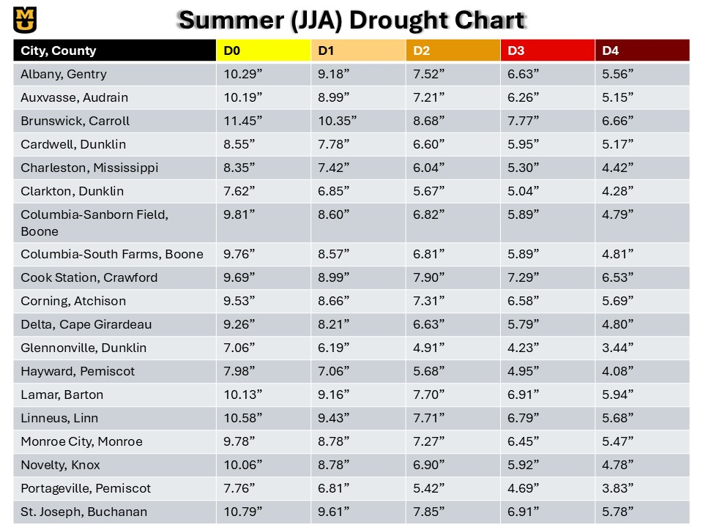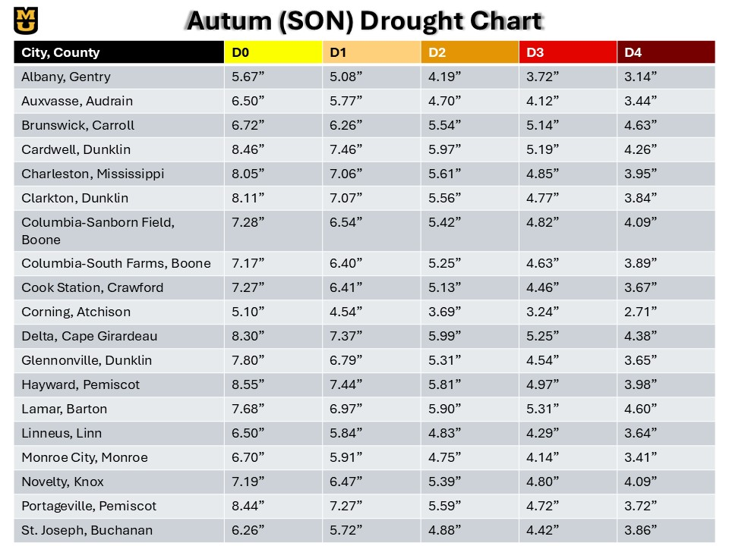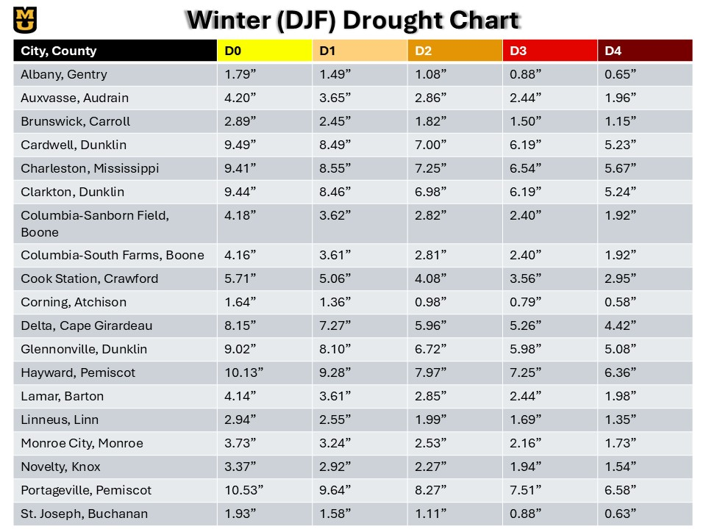

# Appendix C: Mesonet Station Summaries

